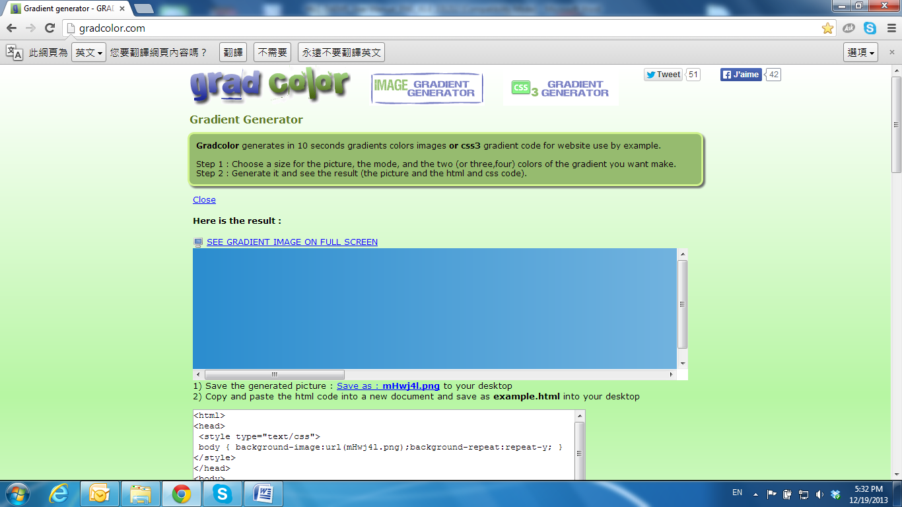

Network Configuration

1. Configuration 1:  
   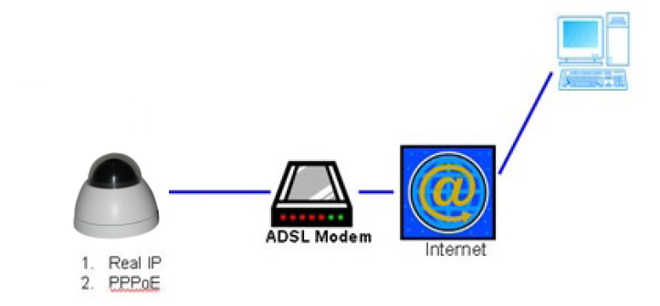
   * 1. Internet Access: ADSL or Cable Modem
     2. IP address: One real IP or one dynamic IP
     3. Only the IP Camera is connected to the internet
     4. For fixed real IP, set up the IP into IP Camera. For dynamic IP, start PPPoE.
2. Configuration 2:  
   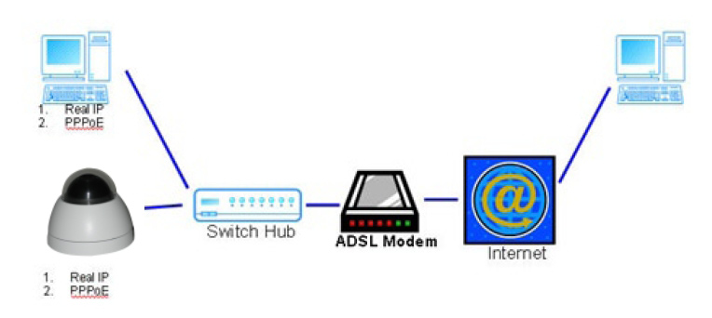
3. Internet Access: ADSL or Cable Modem
4. IP address: More than one real IP or one dynamic IP
5. IP Camera and PC connect to the internet
6. Device needed: Switch Hub.
7. For fixed real IP, set up the IP into IP Camera and PC. For dynamic IP, start PPPoE.
8. Configuration 3:  
   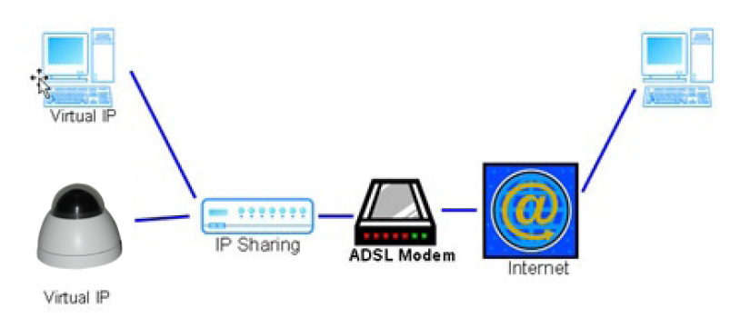
9. Internet Access: ADSL or Cable Modem
10. IP address: one real IP or one dynamic IP
11. IP Camera and PC connect to the internet
12. Device needed: IP sharing
13. Use virtual IP, set up port forwarding in IP sharing.